Linux

1. **Open Source**
   1. **Linux Evolution And popular Operating Systems**
2. **Linux Embedded systems**

A combination of hardware and software for specific purpose

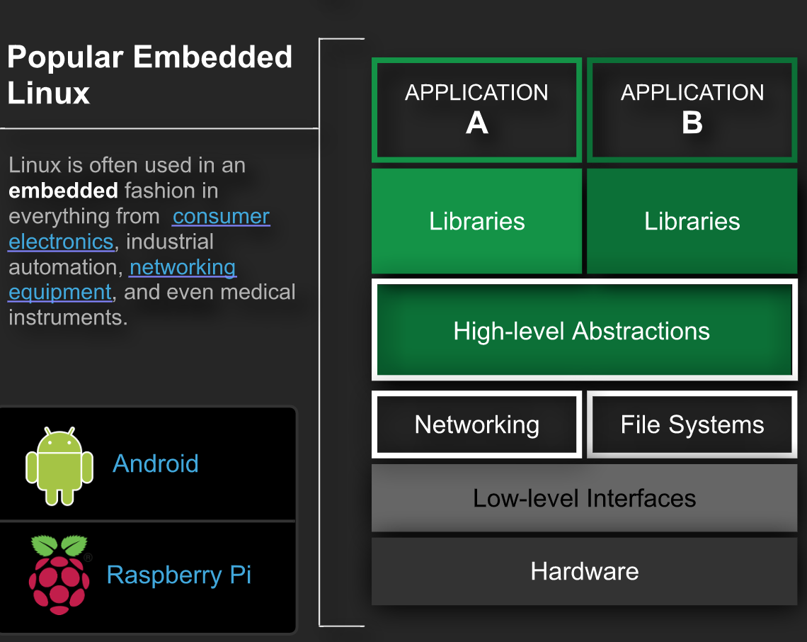

**Consumer Electronics:**

Operating systems based on the Linux kernel used in embedded system for consumer electronics include:

* Set top boxes
* Smart TVs
* In-vehicle entertainment

Many manufactures, when using system on chips, will use their own proprietary version of Linux.

The open source kernel forms the foundation of the operating system, however their own internally-developed drivers and software control the device.

**Network equipment:**

Operating systems based on the Linux kernel used in embedded systems for networking equipment include:

* Routers
* Switches
* Wireless access points (WAPs)
* Wireless routers

A standard Linux installation typically has all of the software necessary to be a fully functional router.

Netlifier, framework within the Linux kernel used for firewalls, also provides the hooks and capabilities necessary to track and manage connections across any number of interfaces.

Right out of the box it can provide encryption, proxy, and deep packet inspection capabilities.

**Android:**

Designed and maintained by Google,

Android is a mobile operating system based on a modified version of the Linux kernel.

**Raspberry Pi:**

